Mesa Ridge High School Indoor Athletics EAP
Revised 2017

Address: 6070 Mesa Ridge Parkway

The first coach to scene should assess responsiveness and vital signs and should have another coach activate EMS.
Send an assistant coach or athlete to notify the athletic trainer of the situation.
Assess pulse and breaths.

EMS Activation
Activate EMS by calling 911
  - Caller name
  - Address: 6070 Mesa Ridge Parkway
  - What facility the emergency is in
  - The nature of the emergency
  - The number of athletes/people involved
  - Condition of the athletes
  - If first aid was administered
  - Any other information the dispatch needs

Care for injured individual as necessary
Emergency equipment retrieval
- Spine board between fridge & wall
- Splint kit in first cabinet as you walk in the room
- Crutches on the right of the refrigerator
Open doors for EMS & have caller wait for them to arrive
Scene Control: limit scene to first aid responders and move bystanders away from the area

Venue Directions
Gymnasium- Enter the side door on the west side of the building and “The Cave” (main gym) is the second gym on the right. “The Den” (auxiliary gym) is the first gym on the right.

Wrestling room- Enter the side door on the west side of the building and the wrestling room is on the left.

Weight room- Enter the side door on the west side of the building. Take a left down the hallway and the weight room is the second room on the right.
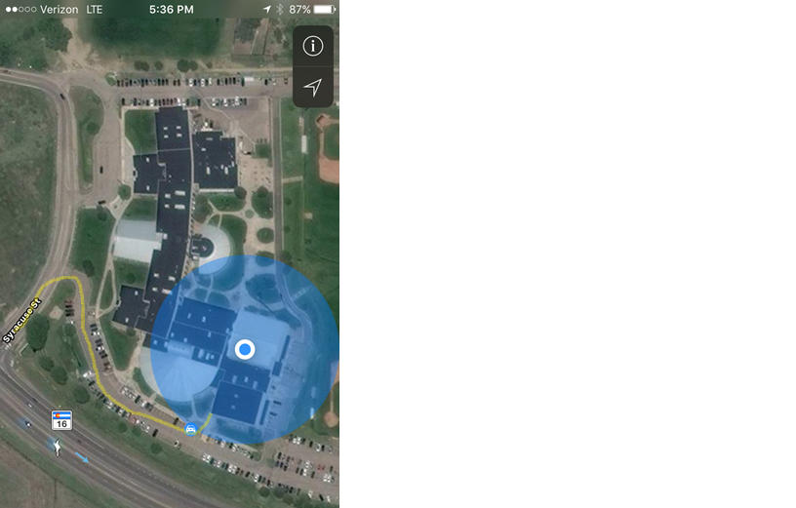

The yellow line demonstrates what door to enter from the parking lot.

Emergency Personnel
Athletic Trainers- Located either in the gym or in the Athletic Training Facility across the hall from the gym.
Athletic Director/Administrator
Coaches- Located in the gym/wrestling/weight room depending on the sport.

Emergency Communication
There is a landline in the office of the Athletic Training Facility across the hall from the gym.
Athletic Trainer’s Cell Phone (719) 229-3462
Athletic Trainer’s personal Cell Phone (719) 761-9000
Athletic Director Cell Phone (719) 250-9907

Emergency Equipment (AED, vacuum splints, crutches, spine board) located in the Athletic Training Facility across the hall from the gym.

Emergency Team Members | Skill Proficiency
Certified Athletic Trainer | - Prevention of Injuries  - Recognition, Assessment and Immediate Care of Injuries (Initiation of Spine Boarding)  - Education Counseling  - Liaison between Coach, Athletes, MD and Parents
First Responder/Athletic Training Students | - Basic Life Support and stabilization until ambulance arrives  - Splinting and Bandaging  *Do not initiate spine boarding but may provide assistance
EMT | - Initiation of Spine Boarding  - Advanced Airway Management  - Administration of Medication  - Advanced Cardiac Support  - Transportation of Injured Athlete

Inclement Weather
Tornado
In case of a tornado, both teams should find cover in their appropriate locker rooms. Once there, line up against the lockers and sit on knees with hands over head in a crouched position facing the lockers. Coaches should join their players. Spectators should exit the gymnasium in an orderly fashion and line up in the hallway across from the gym. They should then get in the same position mentioned before along the lockers, being sure to be away from any windows or glass objects. Athletic Staff (Athletic Trainers, Athletic Director, etc) should go to the Athletic Training Facility to monitor the weather on the computer and get into said crouched position when necessary.

Play may continue after the “all clear” has been given by the Athletic Trainer only if there is no danger due to the weather.

Lightening
Not applicable in indoor sports.

